Date | 31 January 2026
Team ID | LTVIP2026TMIDS35189
Project Name | Heart Diesease Analysis
Maximum Marks | 4 Marks

DATA FLOW DIAGRAM
A Data Flow Diagram (DFD) is a traditional visual representation of the information flows within a system. A neat and clear DFD can depict the right amount of the system requirement graphically. It shows how data enters and leaves the system, what changes the information, and where data is stored.

User Type | Functional  Requirement  (Epic) | User  Story  Number | User Story / Task | Acceptance Criteria | Priority | Release
Data Analyst | Data Collection | USN-1 | As a data analyst, I want to extract data from CSV/onl  ine sources for analysi | Data is successfully extracted without errors | High | Sprint-1

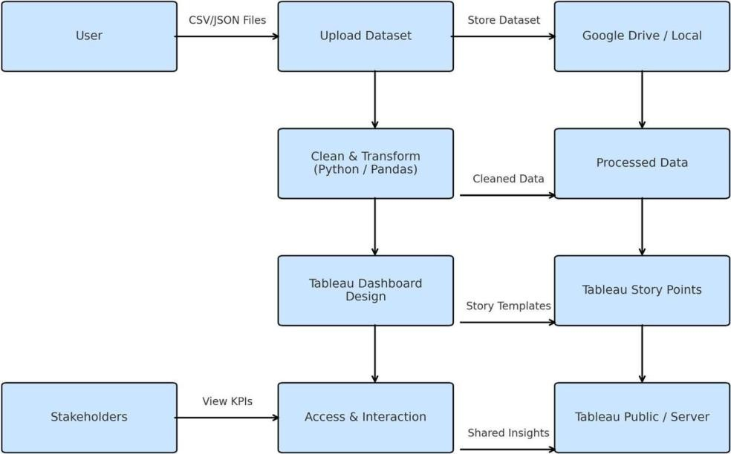

User stories:

Use the below template to list all the user stories for the product.

User Type | Functional  Requirement  (Epic) |  | User  Story  Number |  | User Story /  Task | Acceptance Criteria | Priority | Release
Data Analyst | Data  Extraction |  | USN-2 |  | As a data analyst, I want to clean and preprocess heart disease data to remove missing and inconsiste nt values. | Clean and structured dataset is available | High | Sprint-1
Data Analyst | Data  Preparation |  | USN-3 |  | As a data analy regions. | Analytical charts and insights are generated | Medium | Sprint-1
Data Analyst | Market  Analysis |  | USN-4 |  | As a business user, I want to view visual charts showing heart disease patterns and risk factors. | Interactive visualization s are displayed correctly | High | Sprint-1
Business User | Data  Visualization |  | USN-5 |  | As a business user, I want to view visual charts showing iPhone sales trends and growth. | Interactive visualizations are displayed correctly | High | Sprint-1
Business User | Dashboard |  | USN-6 |  | As a business user, I want a single dashboard to view all key iPhone market insights. | Dashboard displays all important KPIs and charts | High | Sprint-1
Stakeholder |  | Story |  | USN-7 | As a stakeholder, I want a Tableau story to understand insights step by step. | Story presents insights in a clear sequence | Medium | Sprint-2
 |  |  |  |  |  |  | Sprint-2
User Type |  | Functional  Requirement  (Epic) |  | User  Story  Number | User Story / Task | Acceptance Criteria | Priority | Release
Project Manager |  | Report |  | USN-8 | As a project manager, I want a report summarizing the analysis and insights. | Report includes visuals and explanations | High Sprint-2
Administrator |  | Performance  Testing |  | USN-9 | As an administrator, I want to test dashboard performance for smooth interaction. | Dashboard loads within acceptable time | Low Sprint-2
Administrator |  | Web  Integration |  | USN-10 | As an  administrator, I want to integrate the Tableau dashboard into a web application. | Dashboard is accessible through a web browser | Medium Sprint-2
End User |  | Online Access |  | USN-11 | As an end user, I want to access the iPhone  analysis dashboard online without installing Tableau. | Dashboard opens successfully via web link | Medium Sprint-2

